**NAME: SYED MEASUM HASSAN**

**ROLL NO: 20B-058-SE**

**SEC: B**

**LAB 2 PERFORMANCE**

*OUTPUTS OF ALL CODES:*

**TASK 1:**

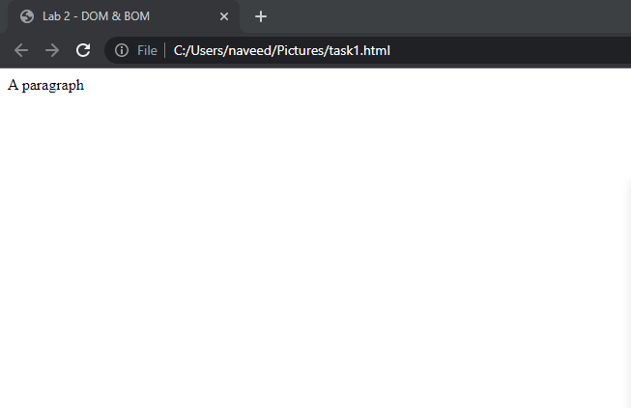

**TASK 2:**

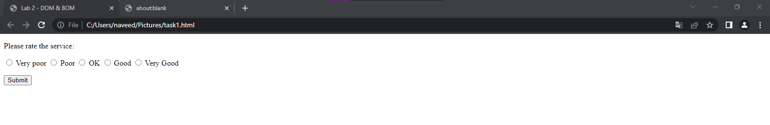

**TASK 3:**

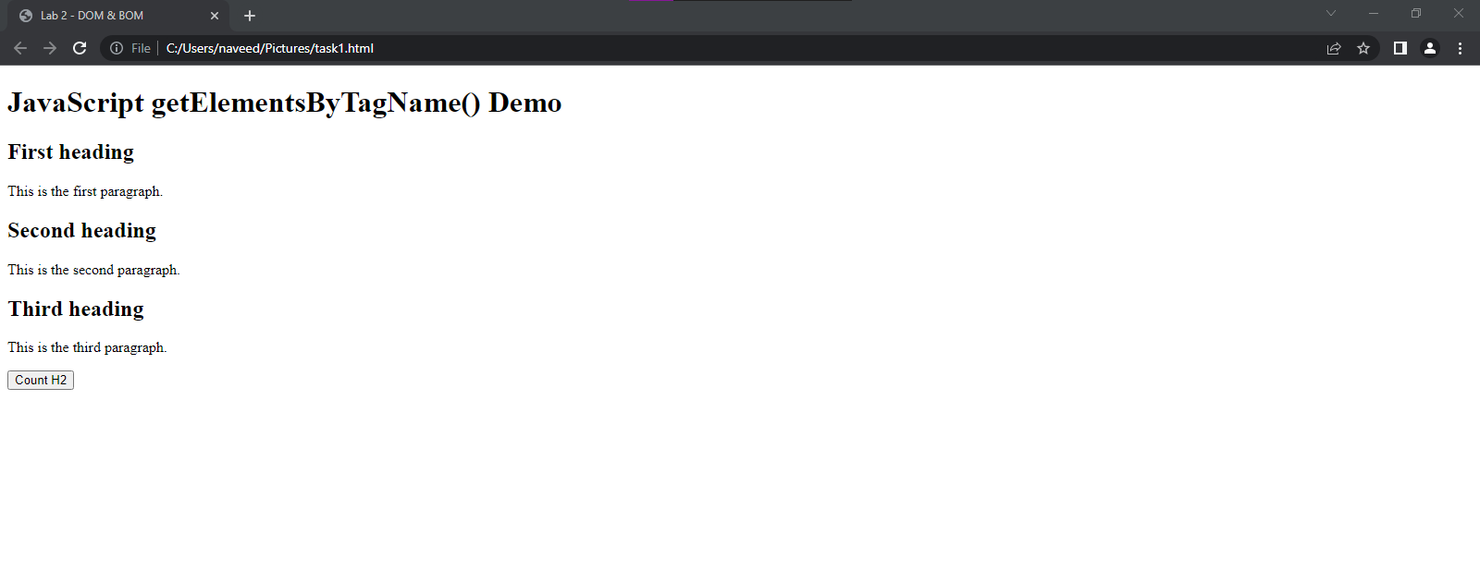

**TASK 4:**

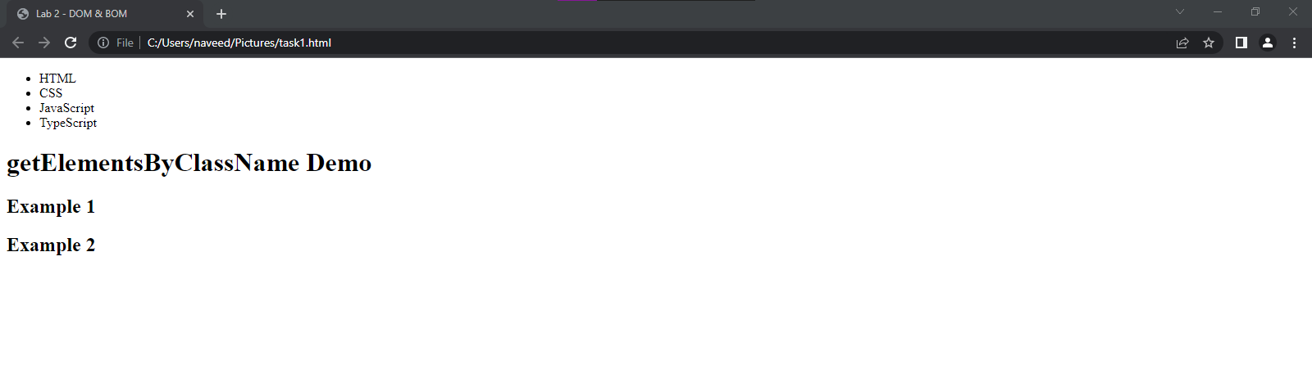

**TASK 5:**

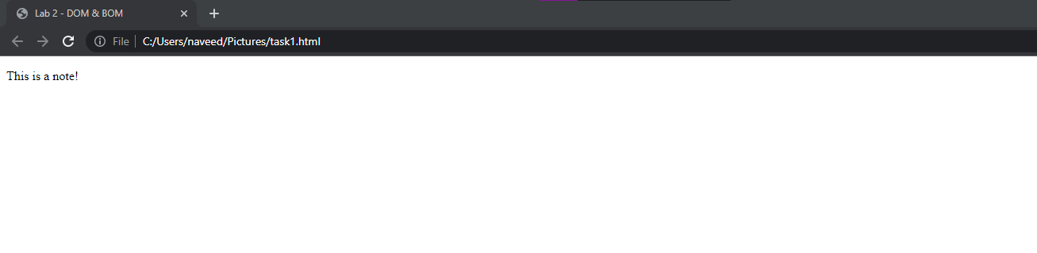

**TASK 6:**

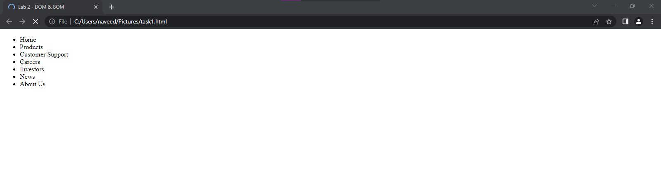

**TASK 7:**

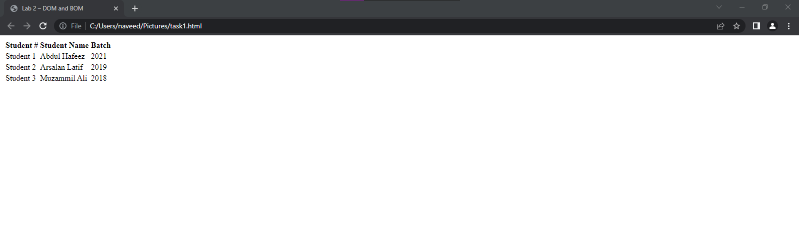

**TASK 8:**

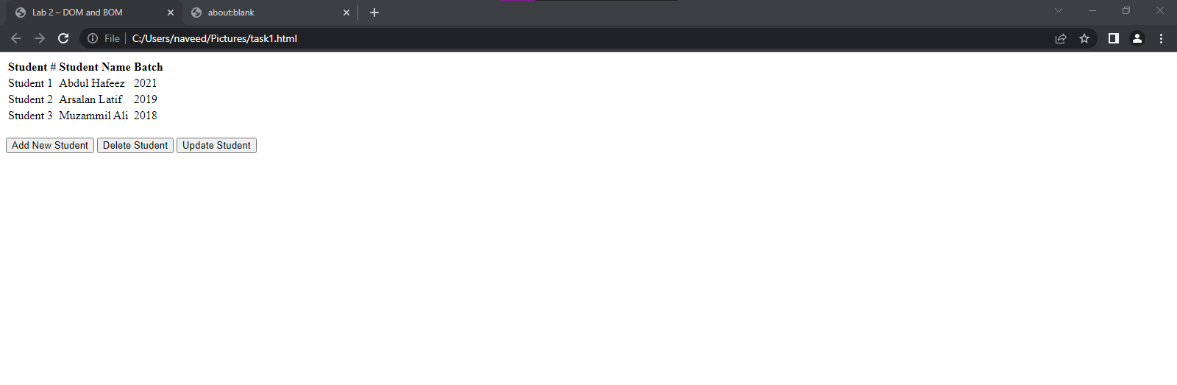

**TASK 9:**

